Module 2-Assignment

1. Write a C program to define 3 different threads with the following purposes where N is the input
Thread A-To run a loop and return the sum of first N prime numbers
Thread B & C - should run in parallel. One prints "Thread 1 running" every 2 seconds, and the other prints "Thread 2 running" every 3 seconds for 100 seconds.
#include <stdio.h>
#include <pthread.h>
#include <unistd.h>

int N;

// Thread A
void *primeSum(void *arg)
{
int count = 0, num = 2, sum = 0, i, prime;

while(count < N)
{
prime = 1;

for(i = 2; i < num; i++)
{
if(num % i == 0)
{
prime = 0;
break;
}
}

if(prime == 1)
{
sum = sum + num;
count++;
}

num++;
}

printf("Sum of first %d prime numbers = %d\n", N, sum);
return NULL;
}

// Thread B
void *thread1(void *arg)
{
int i;

for(i = 1; i <= 50; i++)
{
printf("Thread 1 running\n");
sleep(2);
}

return NULL;
}

// Thread C
void *thread2(void *arg)
{
int i;

for(i = 1; i <= 33; i++)
{
printf("Thread 2 running\n");
sleep(3);
}

return NULL;
}

int main()
{
pthread_t t1, t2, t3;

printf("Enter N: ");
scanf("%d", &N);

pthread_create(&t1, NULL, primeSum, NULL);
pthread_create(&t2, NULL, thread1, NULL);
pthread_create(&t3, NULL, thread2, NULL);

pthread_join(t1, NULL);
pthread_join(t2, NULL);
pthread_join(t3, NULL);

return 0;
}
OUTPUT:
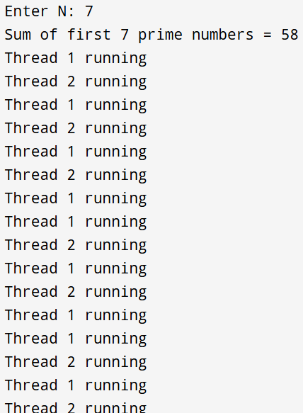

2. In the above program,
add signal handling for SIGINT (etc) and prevent termination.
Convert the above threads to individual functions and note down the time taken and the flow of execution.
#include <stdio.h>
#include <pthread.h>
#include <unistd.h>
#include <signal.h>
#include <time.h>

int N;

// Signal Handler
void handleSignal(int sig)
{
printf("\nSIGINT received! Program will continue running.\n");
}

// Thread A
void *primeSum(void *arg)
{
int count = 0, num = 2, sum = 0, i, prime;

while(count < N)
{
prime = 1;

for(i = 2; i < num; i++)
{
if(num % i == 0)
{
prime = 0;
break;
}
}

if(prime == 1)
{
sum += num;
count++;
}

num++;
}

printf("Sum of first %d prime numbers = %d\n", N, sum);
return NULL;
}

// Thread B
void *thread1(void *arg)
{
int i;

for(i = 1; i <= 50; i++)
{
printf("Thread 1 running\n");
sleep(2);
}

return NULL;
}

// Thread C
void *thread2(void *arg)
{
int i;

for(i = 1; i <= 33; i++)
{
printf("Thread 2 running\n");
sleep(3);
}

return NULL;
}

int main()
{
pthread_t t1, t2, t3;
time_t start, end;

signal(SIGINT, handleSignal); // Handle Ctrl+C

printf("Enter N: ");
scanf("%d", &N);

start = time(NULL);

pthread_create(&t1, NULL, primeSum, NULL);
pthread_create(&t2, NULL, thread1, NULL);
pthread_create(&t3, NULL, thread2, NULL);

pthread_join(t1, NULL);
pthread_join(t2, NULL);
pthread_join(t3, NULL);

end = time(NULL);

printf("\nTime taken = %ld seconds\n", end - start);

return 0;
}
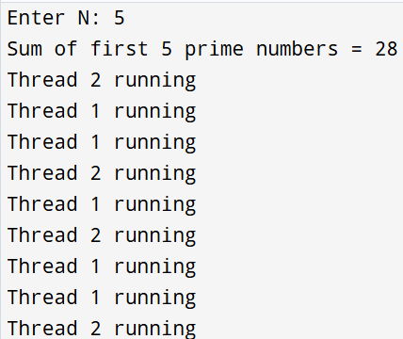
3. Know about the following topics and explore them (Write a note on your understandings)
Areas for exploration,
Child process - fork()
Handing common signals
Exploring different Kernel crashes
Time complexity
Locking mechanism - mutex/spinlock
1. Child Process – fork()
A child process is a new process created from another process called the parent process using fork() in Linux/Unix. Both parent and child processes run independently after creation.

Uses
- Multitasking
- Running multiple programs together
- Process management
2. Handling Common Signals
Signals are notifications sent to a process when an event occurs.
Signal | Meaning
SIGINT | Interrupt signal (Ctrl + C)
SIGKILL | Forcefully stops process
SIGSTOP | Pauses process
SIGCONT | Continues paused process

Signal handling helps prevent sudden program termination and improves process control.
3. Exploring Different Kernel Crashes
The kernel is the core part of the operating system. A kernel crash occurs when the system faces a serious error.
Reasons
- Hardware failure
- Driver issues
- Memory errors
- Software bugs
Effects
- System freeze
- Restart
- Data loss
In Linux, this is called Kernel Panic.
4. Time Complexity
Time complexity measures how much time a program takes to execute.
Common Types
Complexity | Meaning
O(1) | Constant time
O(n) | Linear time
O(n²) | Nested loop time
It helps in choosing efficient algorithms and improving performance.
5. Locking Mechanism – Mutex / Spinlock
Locking mechanisms prevent multiple threads from accessing shared data at the same time.

Mutex
- One thread accesses data at a time
- Other threads wait
- Saves CPU usage

Spinlock
- Thread continuously checks for lock
- Faster for short waiting
- Uses more CPU

Difference
Mutex | Spinlock
Thread sleeps while waiting | Thread keeps checking
Less CPU usage | More CPU usage
Used in applications | Used in kernel programming

